**Landing Page**

**Default page when entering. Index.jsp.**

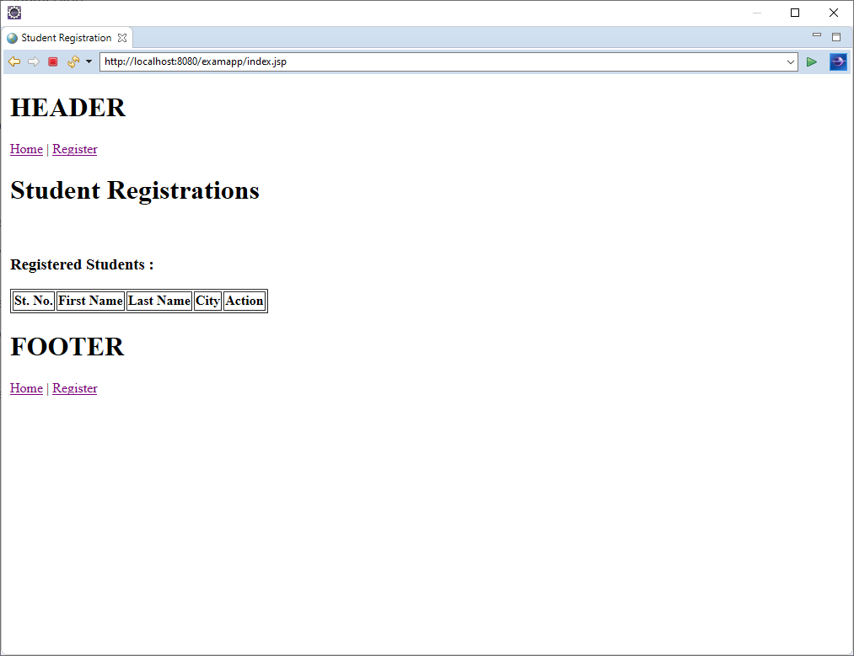

**Register Page**

**Click on register link at top.**

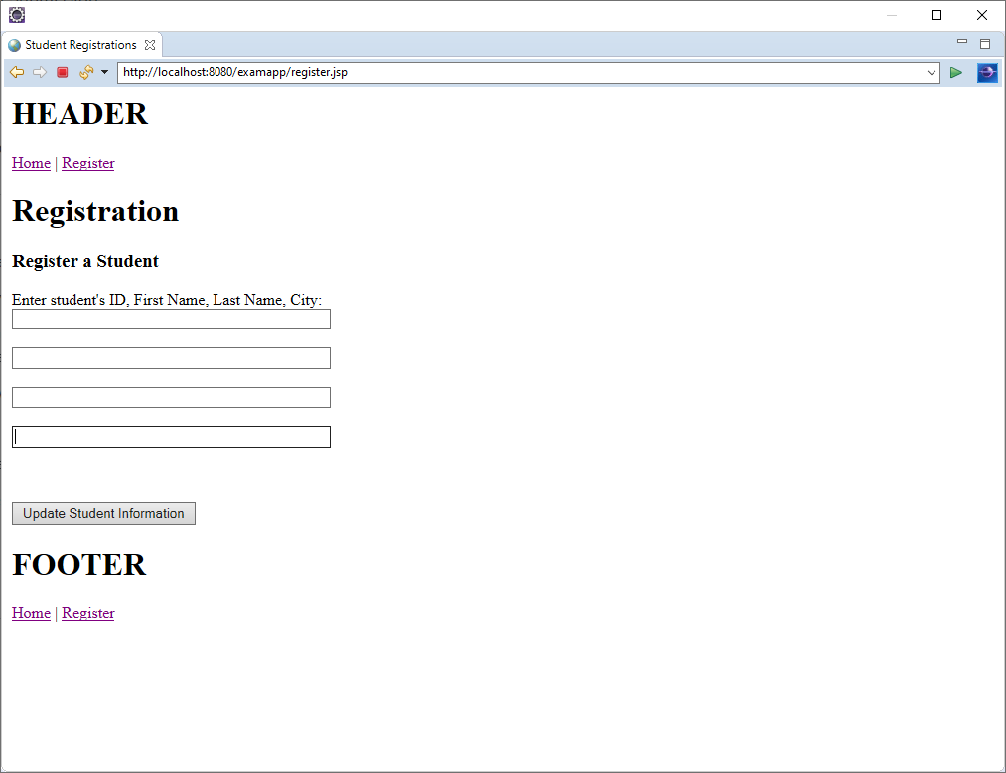

Enter some data for new user.

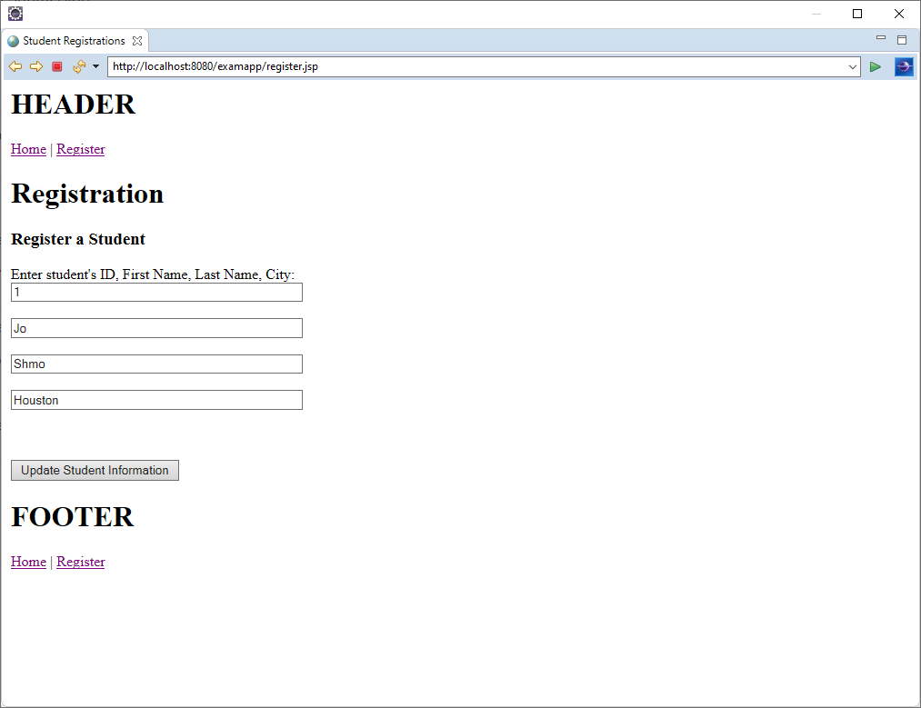

**Home Page**

**After submittal redirects to home page.**

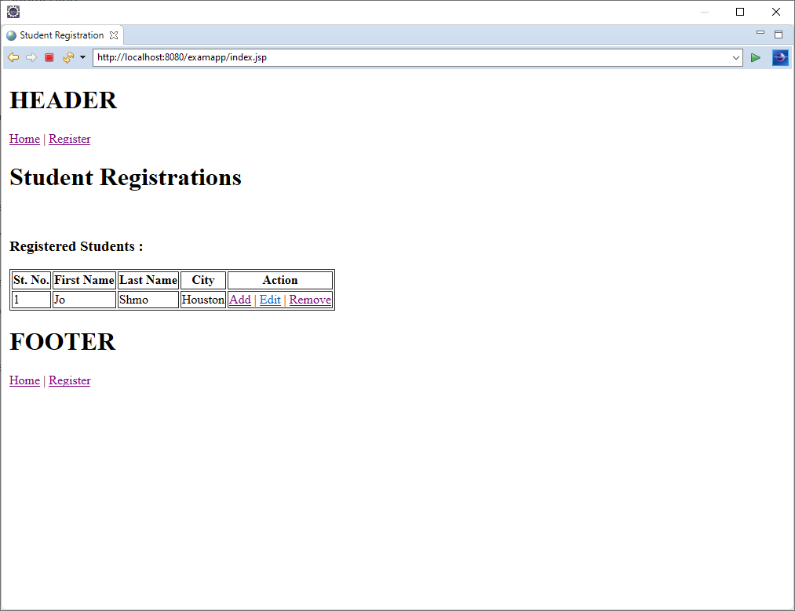

**Add User**

**Click on Add to enter a new user.**

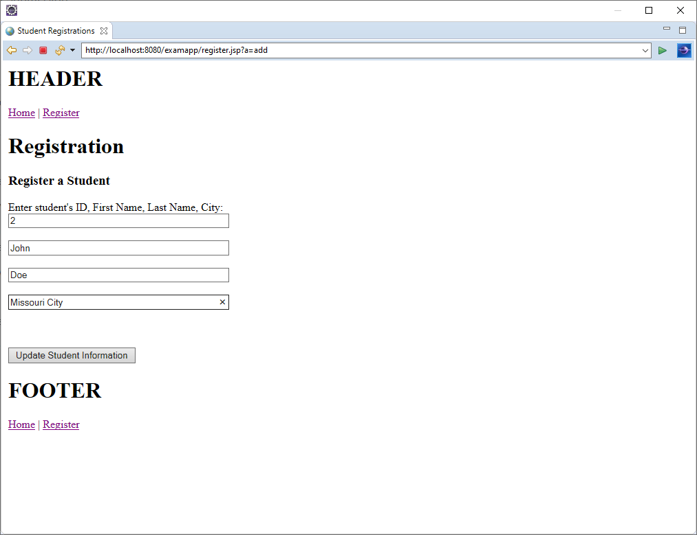

**Edit User**

**Click on Edit link to edit user. Change some data.**

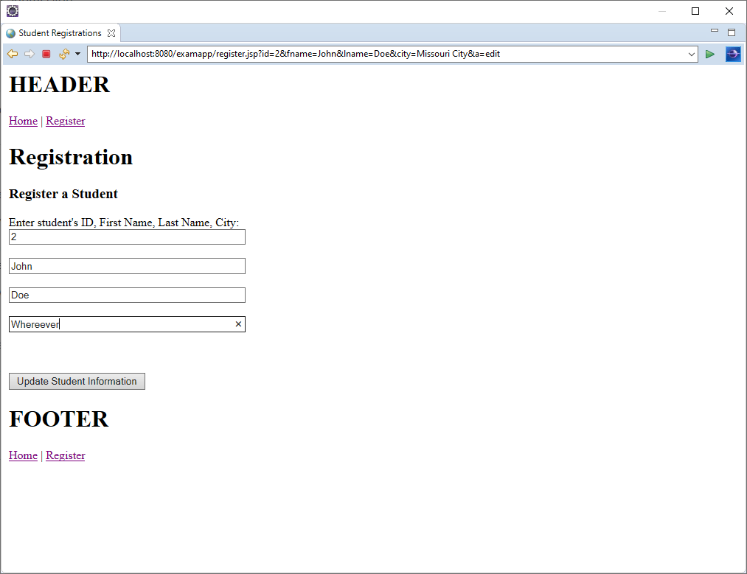

User information is updated and redirect to home page.

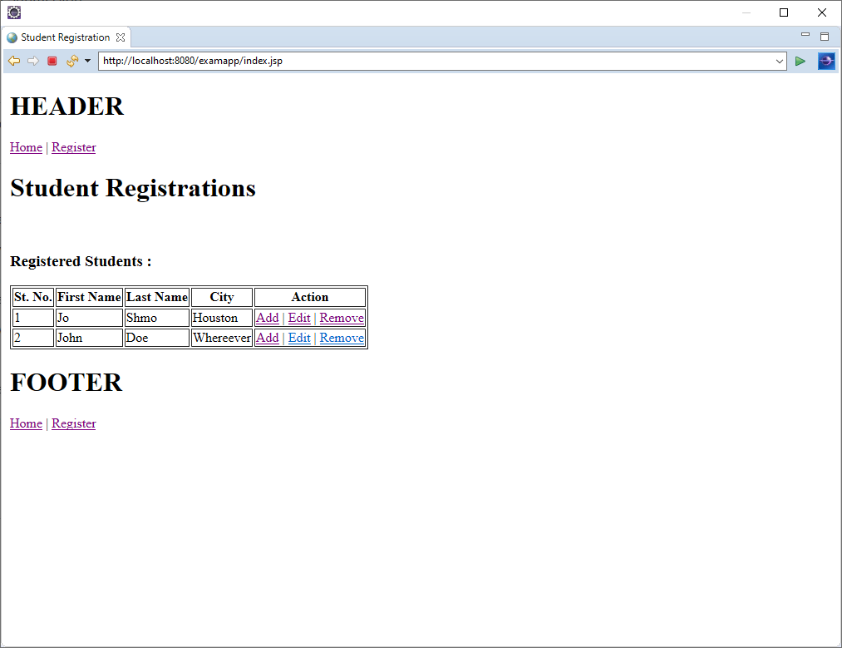

**Remove User**

**Click on remove user for immediate removal and update of display.**

